LFA Service Form
I Customer Information
v. 231226
Company/ Institute
Case no. |  | Customer no.
Contact |  | E-mail
Tel |  | Fax
Address
II Antigen Information
Antigen
Source | ☐ Produced by Croyez  Sequence: _____________________________________________  ☐ Provided by the customer  Antigen brand: __________ Catalog number: _____________
III Antibody Information
Capture antibody
Source | ☐ Produced by Croyez  Sequence: ______________________________________________  ☐ Provided by the customer  Antigen brand: __________ Catalog number: _____________
Detection antibody
Source | ☐ Produced by Croyez  Sequence: ______________________________________________  ☐ Provided by the customer  Antigen brand: __________ Catalog number: _____________
Have you ever tested the antibody pair? | ☐ No  ☐ Yes  ☐ LFA system ☐ ELISA system ☐ Others: ________  If you have experience in testing the antibody pair, please kindly share the validated data.

IV Others
Sample type | ☐ Human serum ☐ Human swab ☐ Others: _________
Describe the design of the lateral flow (ex: indicator line) | Sample graph for your reference (source from website)  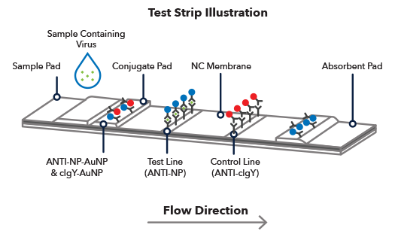

Customer
Sales dept. | Product dept. | Technical dept.

